**a. Setup node js project for student information system**

**to create a student information project in node js**

1.download node js from nodejs.org/eng/download and install it into your system

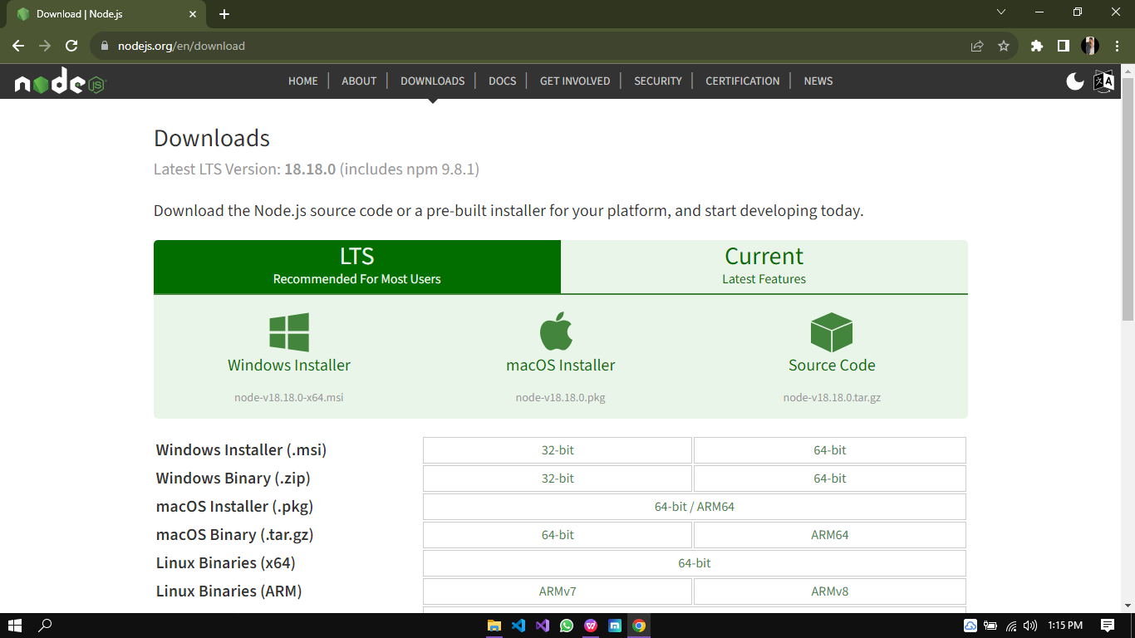

2.create a folder named as student information and create index.js file in it

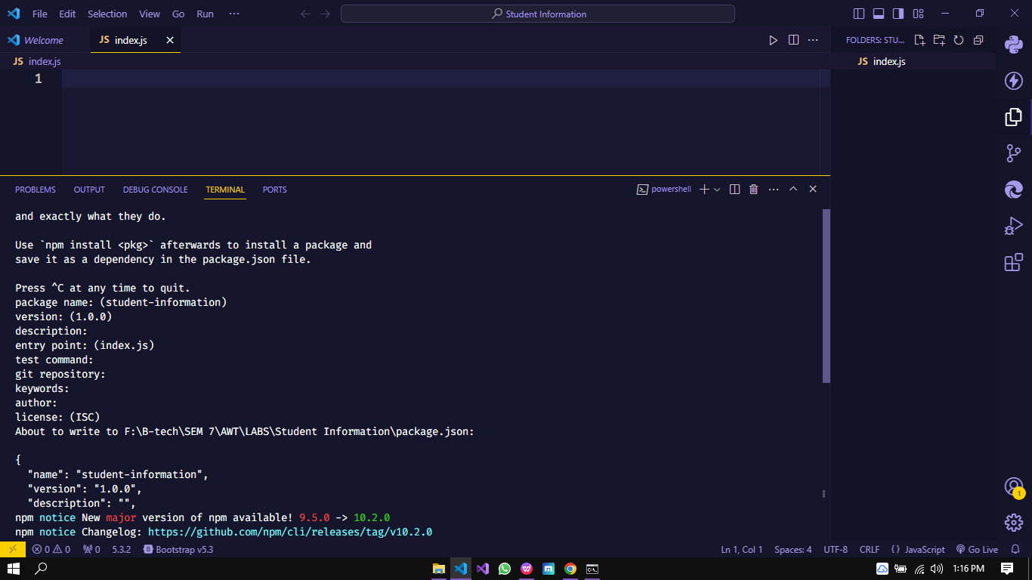

Execute command npm init to initialize nodejs porject

3.install mysql using npm install mysql

4.insall express using npm install express

**b. Setup the database in Node Js**

const mysql = require('mysql')

const express = require('express')

const app = express()

app.use(express.json())

const conn = mysql.createConnection({

    host: 'localhost',

    user: 'root',

    password: '',

    database: 'student_info'

})

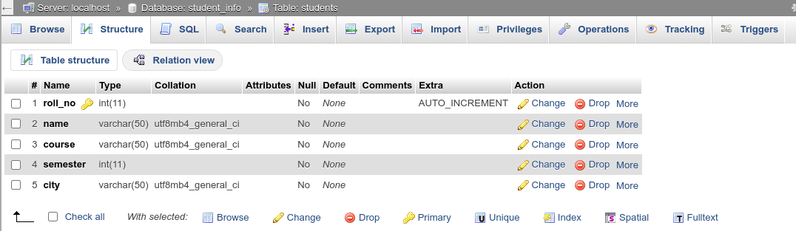

**c. Implement Select Operation in Node Js with Third Party Tool.**

**Code snippet:**

const mysql = require('mysql')

const express = require('express')

const app = express()

app.use(express.json())

const conn = mysql.createConnection({

host: 'localhost',

user: 'root',

password: '',

database: 'student_info'

})

conn.connect((err) => {

if (err) throw err;

else {

console.log('connection success')

app.get('/show', (req, res) => {

data = conn.query('select * from students', (err, result, fields) => {

if (err) throw err;

let jsondata = JSON.stringify(result)

res.send(jsondata)

})

})

**Outcome:**

